**Web Programming**

Class Task-1

**Cat Art Gallery (HTML + CSS)**

Submitted by

Muhammad Moiz Ansari 23i-0523

Semester-6

Submitted to

Ma’am Tajwar



**Department of Computer Science National University of Computer and Emerging Sciences Islamabad, Pakistan**

Contents

Prompt Given 3

Websites by AI 8

1. Claude 8

2. Deep Seek 9

3. Gemini 10

4. Chat Gpt 11

5. Grok 12

AI Agent Comparison Ratings 13

Analysis 13

1. Claude 13

2. DeepSeek 13

3. Gemini 13

4. Chat GPT 13

5. Grok 13

Conclusion 14

# Prompt Given

# Comprehensive Prompt: Cat Art Gallery Website Clone

## **Project Overview**

Create a single-page, responsive website for "Cat Alley Collection" (also referred to as Catalley/Catally), a feline art gallery. The website should capture the whimsical, artistic spirit of cats while maintaining professional web design standards. All code must be in ONE HTML file with embedded CSS.

## **Core Requirements**

### **1. HTML5 Semantic Structure (2 marks)**

- Use proper semantic elements: `<header>`, `<nav>`, `<main>`, `<section>`, `<article>`, `<aside>`, `<footer>`

- Implement semantic tags for content organization

- Ensure logical document outline without using generic `<div>` where semantic tags apply

### **2. CSS Selectors (2 marks)**

- **Type Selectors:** Style HTML elements directly (h1, p, a, etc.)

- **Class Selectors:** Use `.class-name` for reusable styles

- **ID Selectors:** Use `#id-name` for unique elements

- Demonstrate hierarchy: `nav ul li a`

### **3. Navigation Bar with Pseudo-classes (2 marks)**

- Create a fixed/sticky navigation bar with: Home, About, Gallery, Feedback, Sign In, Sign Up

- Implement pseudo-classes for all navigation links:

- `:hover` - change color/background on mouseover

- `:active` - style when being clicked

- `:focus` - style for keyboard navigation accessibility

- Consider `:before` or `:after` for decorative elements

### **4. External CSS Simulation (2 marks)**

- Include all CSS within `<style>` tags in the HTML file

- Organize CSS logically: reset, variables, typography, layout, components, responsive

- Use CSS comments to separate sections

### **5. Visual Design (2 marks)**

- **Background:** Gradient or subtle cat-pattern background image

- **Color Scheme:**

- Primary: Warm tones (oranges, creams for ginger cats)

- Accent: Blues/greys for contrast

- Text: Dark grey/black with white for contrast

- **Fonts:** Use Google Fonts (suggestions: 'Poppins' for headings, 'Open Sans' for body)

- Implement a cohesive color palette using CSS variables

### **6. Creativity & Originality (2 marks)**

- Add subtle cat-themed animations (paw prints, tail wags)

- Create custom cat-shaped elements or borders

- Implement a "cat of the day" feature

- Add interactive hover effects on gallery images

- Include Easter eggs or playful elements consistent with cat theme

### **7. Responsive Design with Media Queries (2 marks)**

- Mobile-first approach

- Breakpoints:

- Mobile: < 768px

- Tablet: 768px - 1024px

- Desktop: > 1024px

- Responsive gallery grid (flexbox or CSS grid)

- Collapsible navigation menu for mobile

- Adjust font sizes, padding, and margins for each viewport

### **8. Typography with Web Fonts (2 marks)**

- Import at least 2 Google Fonts

- Establish typographic hierarchy:

- h1: 2.5rem-3rem

- h2: 2rem-2.5rem

- h3: 1.5rem-1.75rem

- Body: 1rem-1.2rem

- Set proper line-height (1.5-1.6 for body)

- Implement responsive font sizes using `rem` units

### **9. CSS Icons (2 marks)**

- **Font Awesome:** Use for social media, user account, and navigation icons

- **Google Icons/Material Icons:** Use for buttons, forms, and decorative elements

- Implement icon-only buttons for mobile

- Ensure icons are accessible with proper ARIA labels

### **10. Overall Neatness & Professionalism (2 marks)**

- Clean, well-commented code

- Consistent indentation and formatting

- No broken links or placeholder text in final version

- Proper use of whitespace

- Accessible color contrast ratios

- Valid HTML5 and CSS3

## **Page Sections to Implement**

### **Header/Navigation**

- Logo: "Cat Alley Collection" or "Catalley"

- Tagline: "Where Art Has Whiskers"

- Fixed navigation bar with all required links

- Responsive hamburger menu for mobile

### **Hero Section**

- Featured cat artwork

- Main tagline: "Step into a world of feline masterpieces"

- Brief introduction text from screenshot 1

- Call-to-action button to view gallery

### **About Section**

- Title: "Behind the Whiskers"

- Content from screenshot 1: "Cat alley was born from..."

- Student-curated focus

- "Purr-sonality" playful text

### **Gallery Section**

- Grid layout of cat images (minimum 6 as shown in screenshot 2)

- Image titles: Ginger, Shy Cat, Box Cat, Sigma Cat, Minecraft Ginger, etc.

- Hover effects: enlarge, show title overlay, subtle shadow

- Filter options if creative points allow

### **Feedback Section**

- Form with:

- Name field

- Email field with placeholder

- Message textarea

- Submit button

- Design matching screenshot 3

### **Authentication Sections**

**Sign In:**

- Email field

- Password field

- Sign In button

- Link to Sign Up (screenshot 4)

**Sign Up:**

- Email field

- Password field

- Confirm Password field

- Sign Up button

- Link to Sign In (screenshots 5 & 6)

### **Footer**

- Copyright: "© 2026 Catally Art Gallery. All rights reserved."

- Social media links with icons

- Quick links to main sections

## **Technical Implementation Details**

### **HTML Structure**

```html

<!DOCTYPE html>

<html lang="en">

<head>

<meta charset="UTF-8">

<meta name="viewport" content="width=device-width, initial-scale=1.0">

<title>Cat Alley Collection - Where Art Has Whiskers</title>

<!-- Font & Icon Links -->

<!-- Embedded CSS -->

</head>

<body>

<!-- Skip to content link for accessibility -->

<!-- Header with navigation -->

<!-- Main content sections -->

<!-- Footer -->

</body>

</html>

```

### Images Folder

The gallery images are in the folder named "images" of which structure is as follows (all are square images except 'cat-main.png' is horizontal):

images/

├── cat1.png

├── cat2.png

├── cat3.png

├── cat4.png

├── cat5.png

├── cat6.png

├── cat-main.png (if needed)

├── favicon.png

### **CSS Organization**

1. CSS Reset/Normalize

2. CSS Variables (colors, fonts, spacing)

3. Base Styles

4. Layout Styles

5. Component Styles

6. Responsive Media Queries

### **Interactive Elements**

- Smooth scrolling for navigation

- Form validation feedback

- Toggle between Sign In/Sign Up without page reload (optional for creativity)

- Image lightbox for gallery (optional)

### **Accessibility Features**

- Alt text for all images

- ARIA labels for icons

- Keyboard navigation support

- Focus states for all interactive elements

- Sufficient color contrast

## **Deliverables**

1. One HTML file containing all code

2. Fully responsive design tested on mobile, tablet, and desktop

3. All required sections implemented

4. Clean, professional presentation matching the spirit of the screenshots

5. Creative cat-themed enhancements while maintaining usability

## **Evaluation Criteria**

- Adherence to all 10 requirements (2 marks each)

- Visual fidelity to provided screenshots

- Code quality and organization

- Responsive behavior

- Creativity within the cat art gallery theme

- User experience and accessibility

## **Extra Credit Considerations**

- Implement a dark/light mode toggle

- Add a working image filter for gallery

- Create a "random cat fact" generator

- Implement localStorage for form data persistence

- Add subtle CSS animations for page transitions

**Note:** While cloning the design from screenshots, ensure the website has a cohesive identity (choose one name: Cat Alley Collection, Catalley, or Catally) and maintain consistency throughout the implementation.

Please give only HTML + CSS

# Websites by AI

## Claude

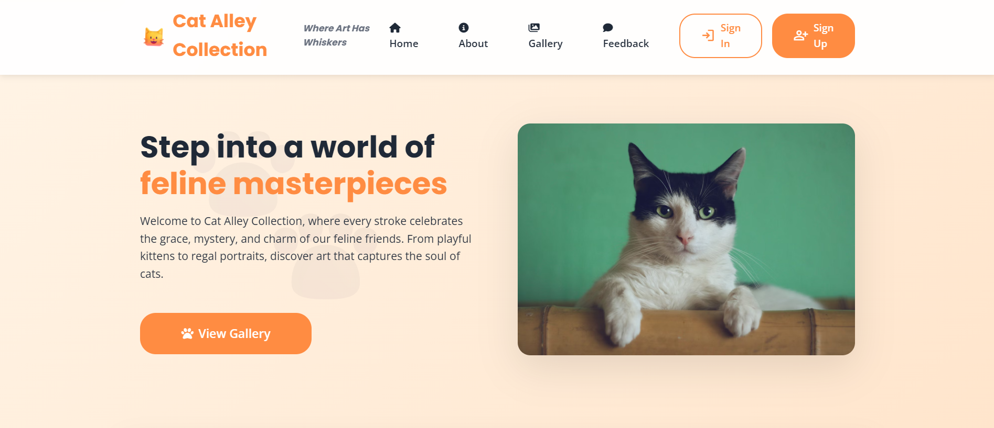

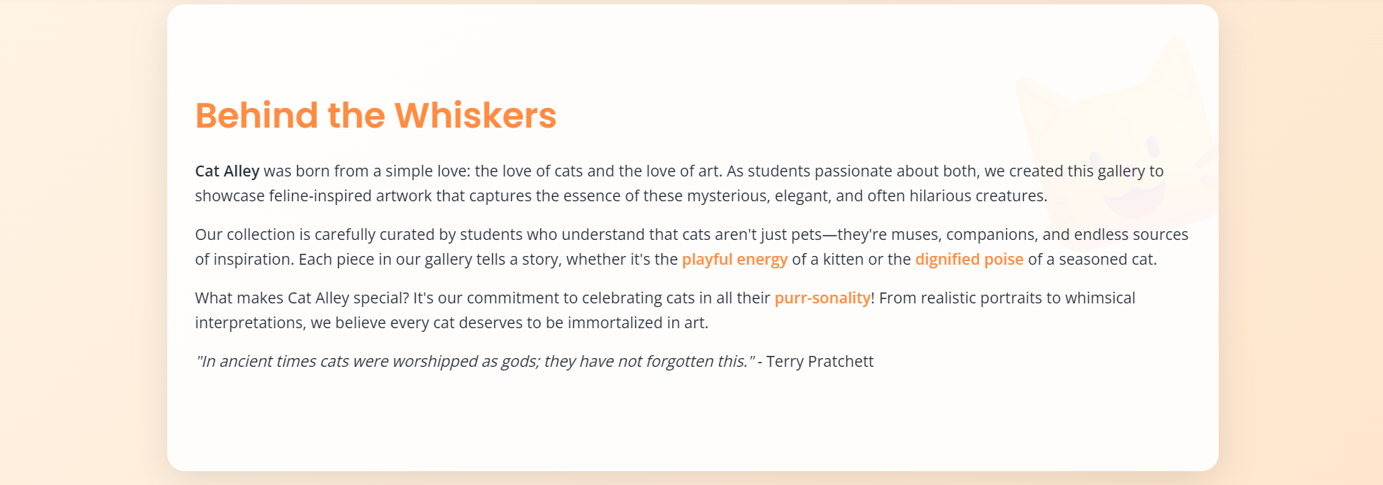

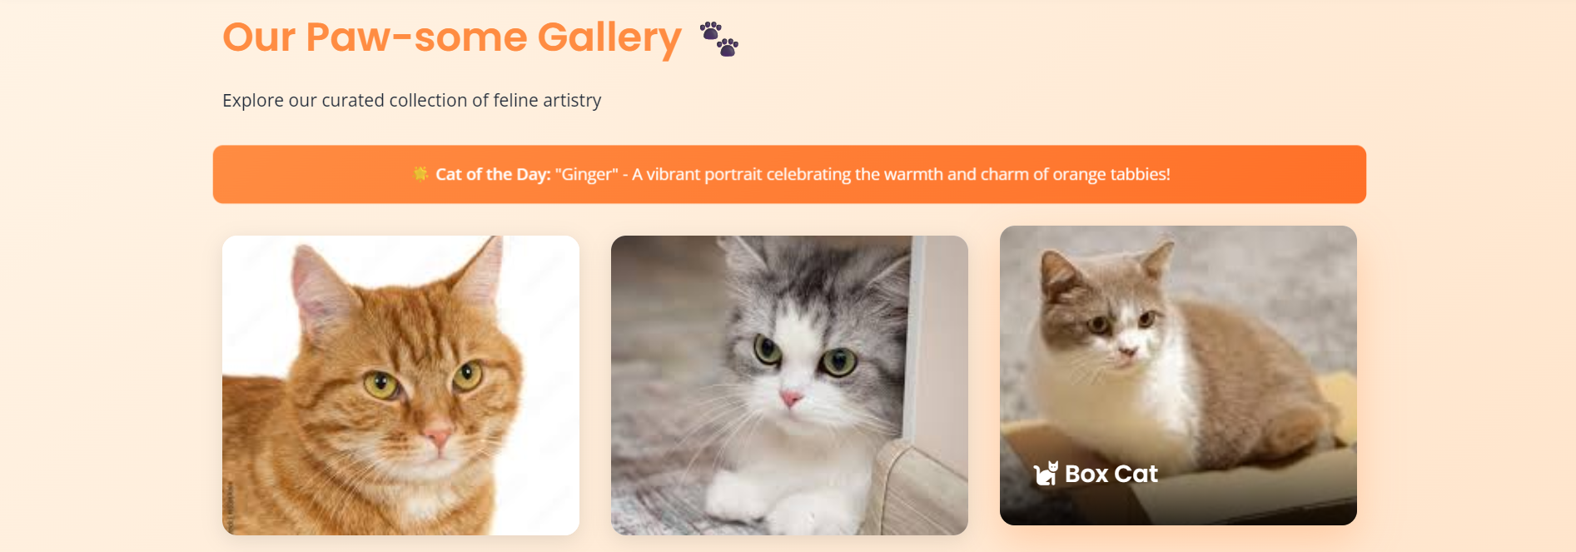

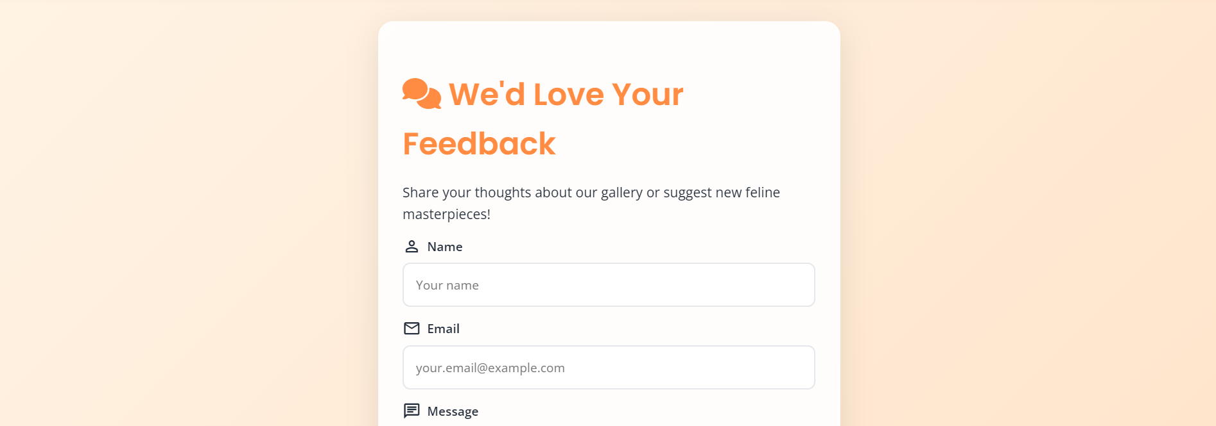

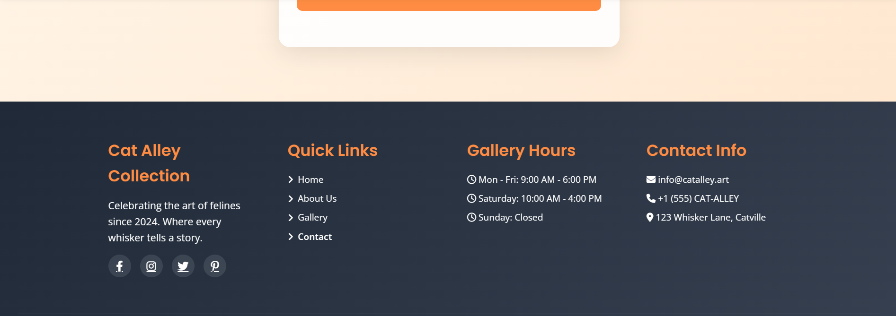

## Deep Seek

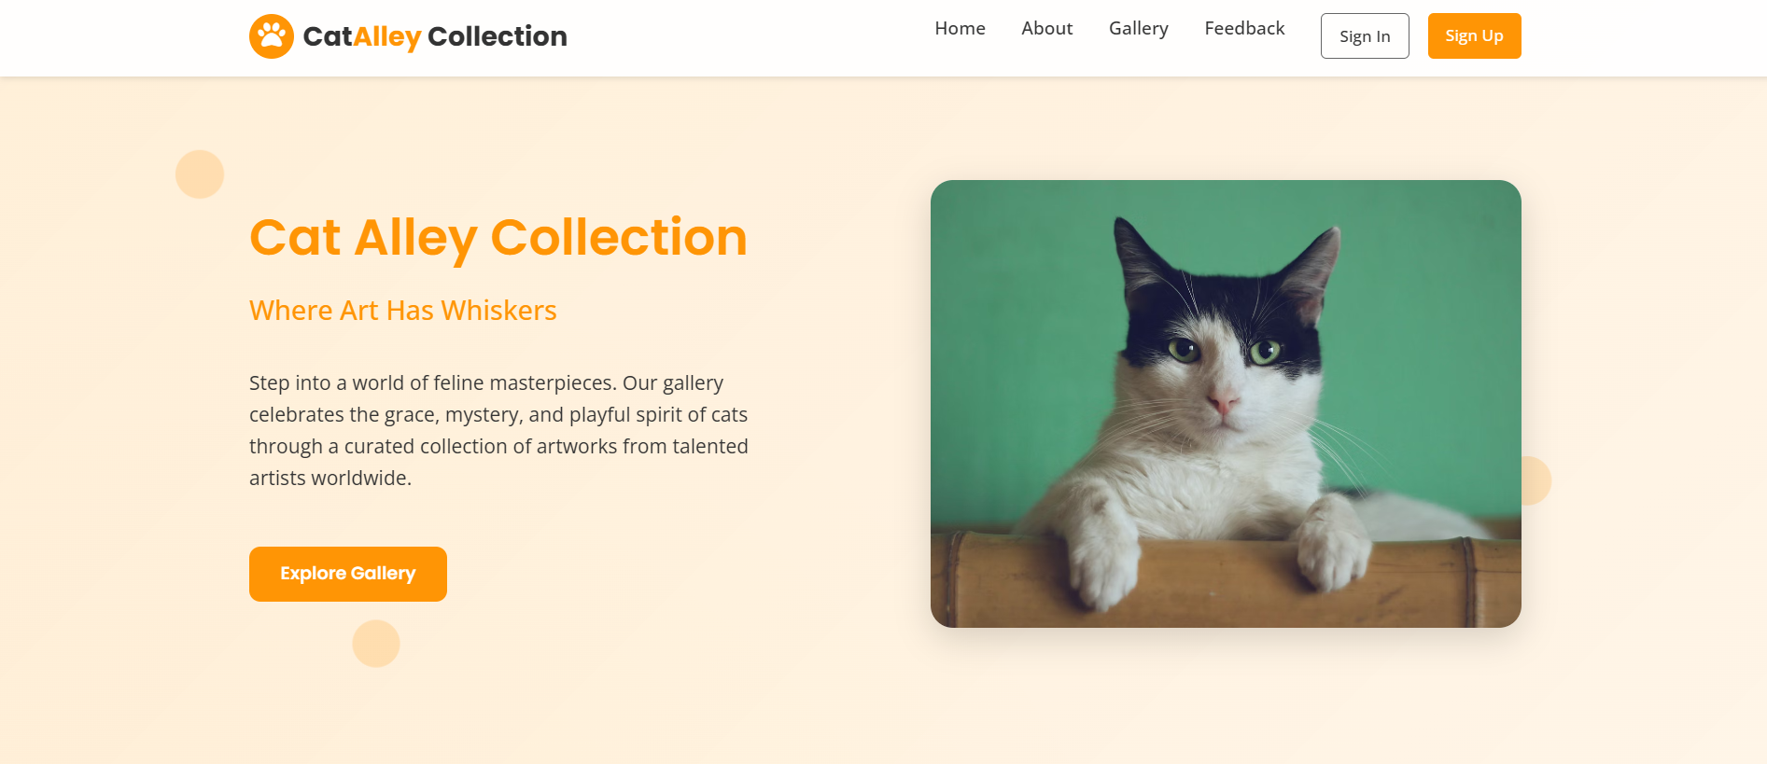

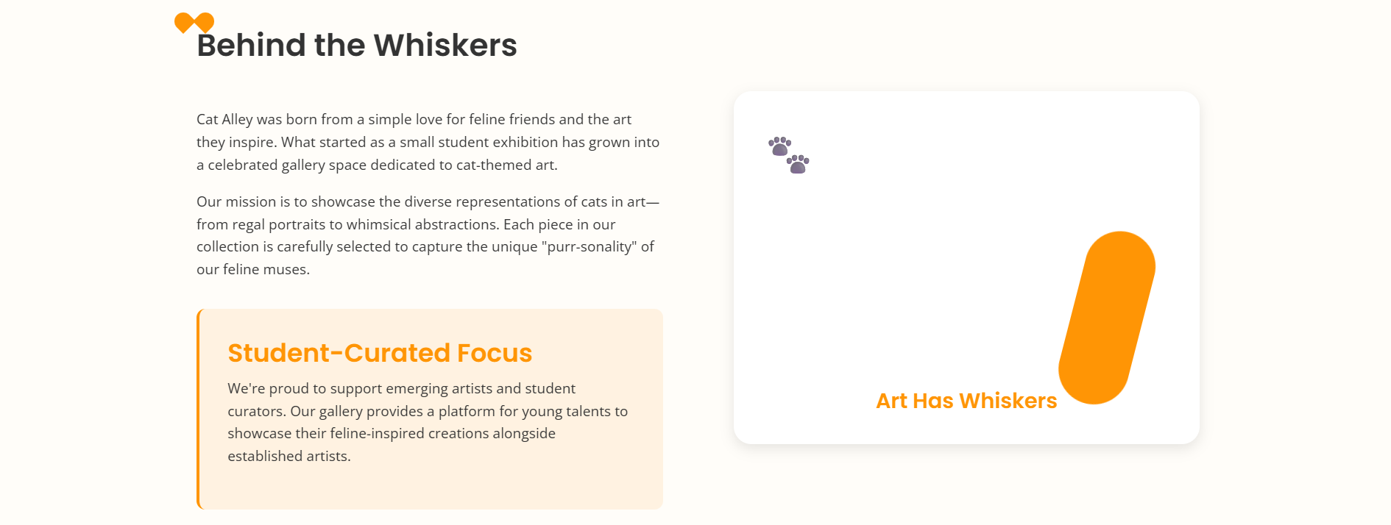

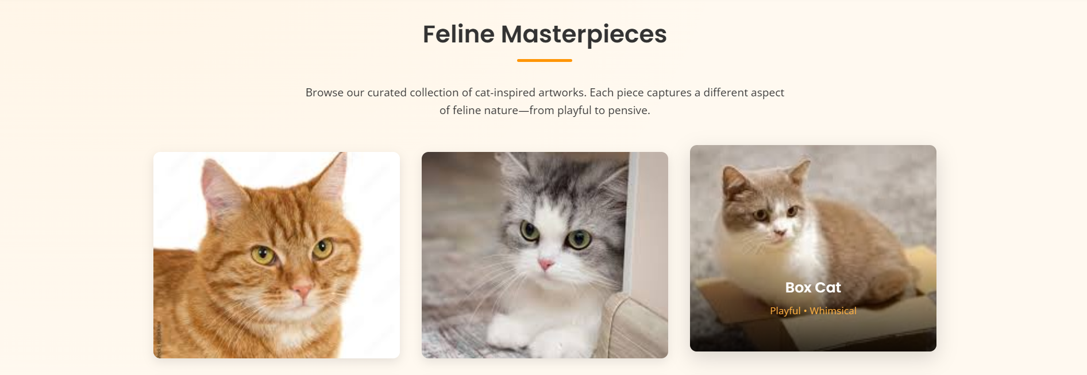

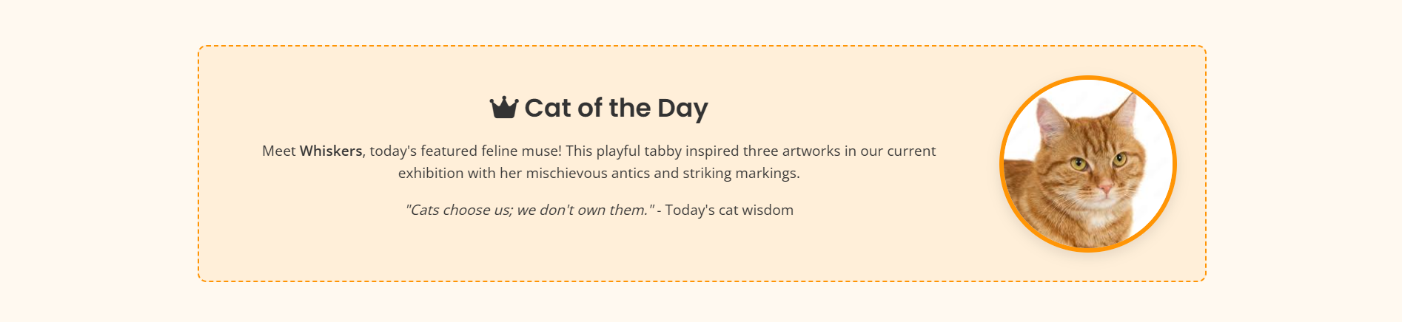

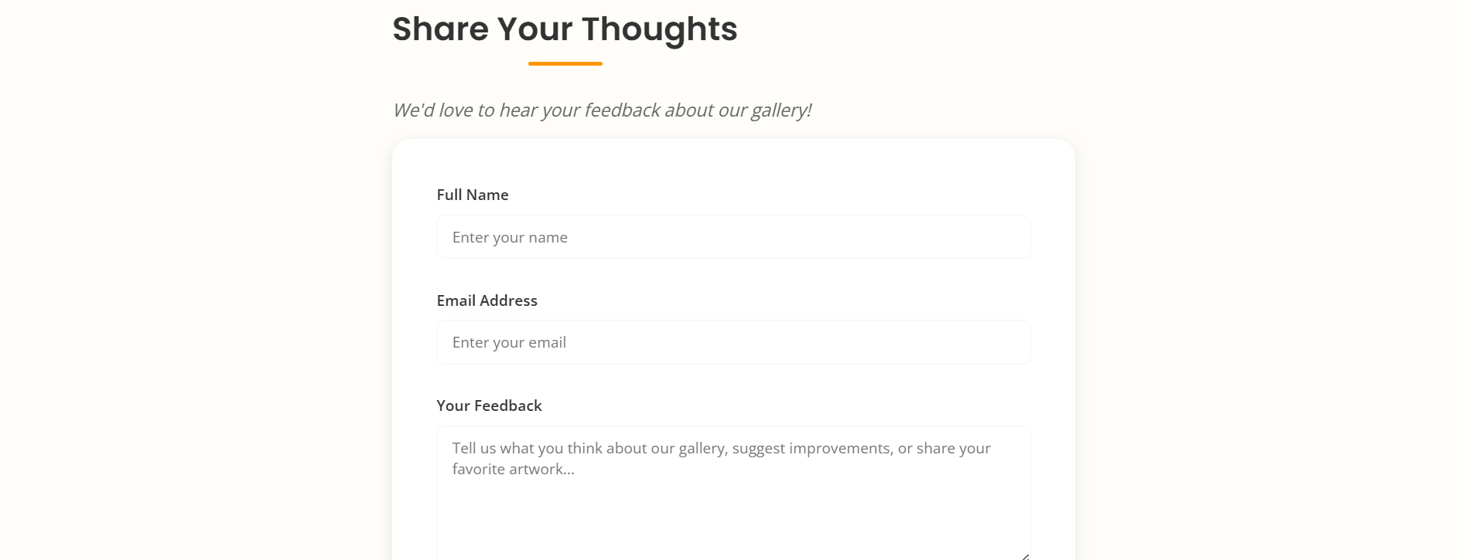

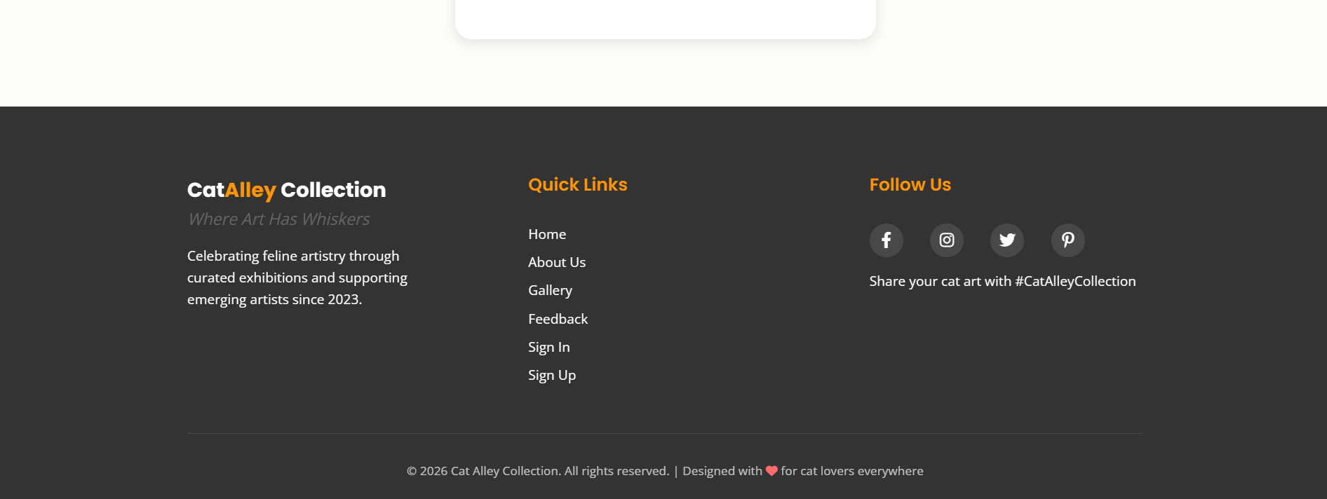

## Gemini

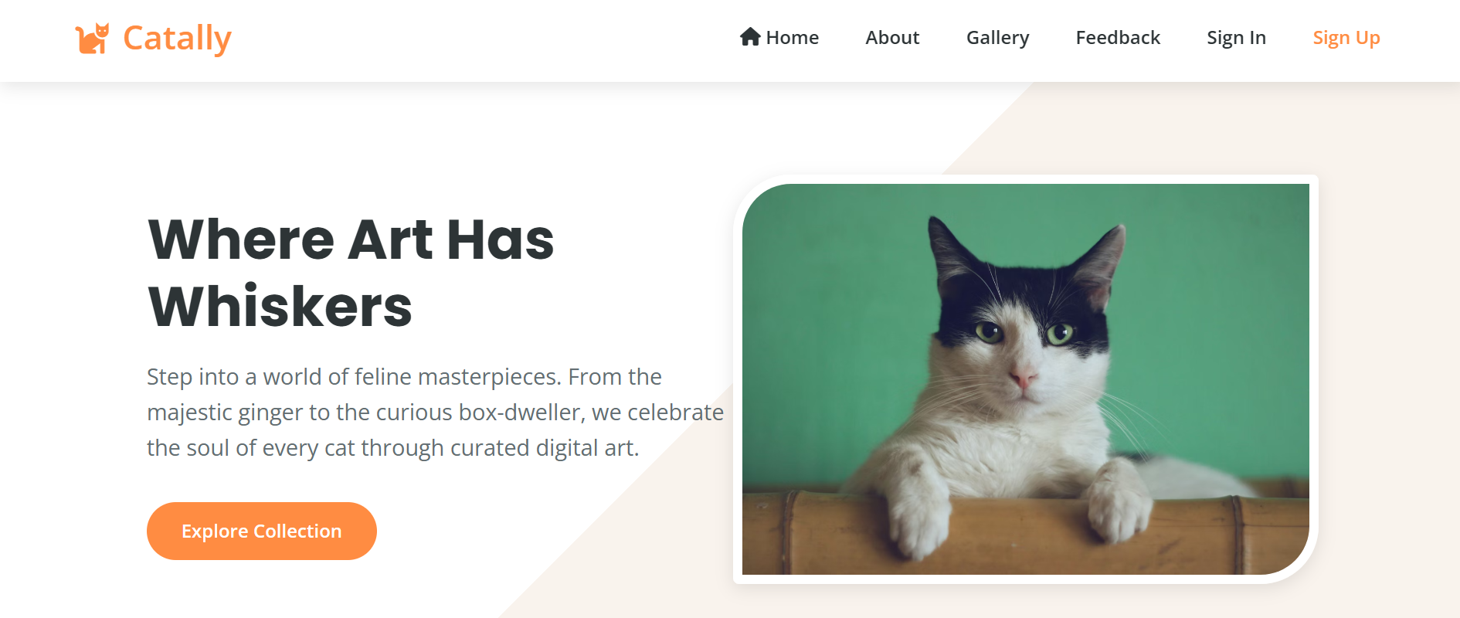

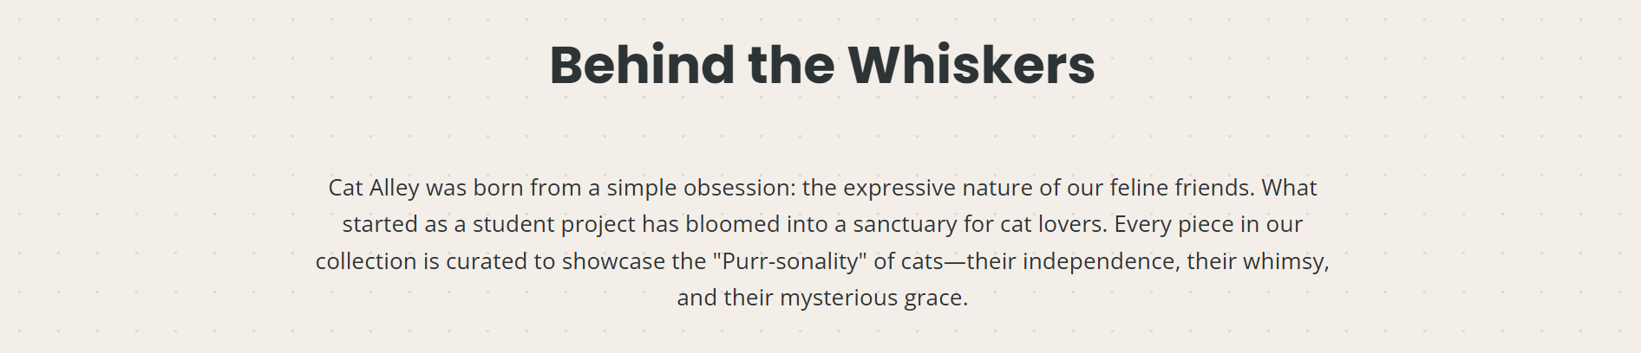

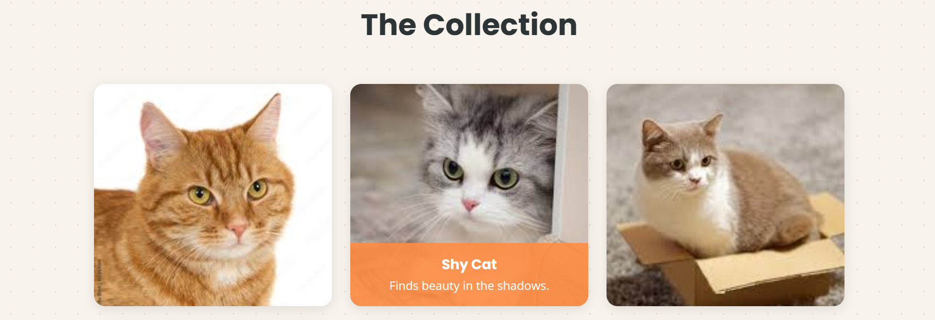



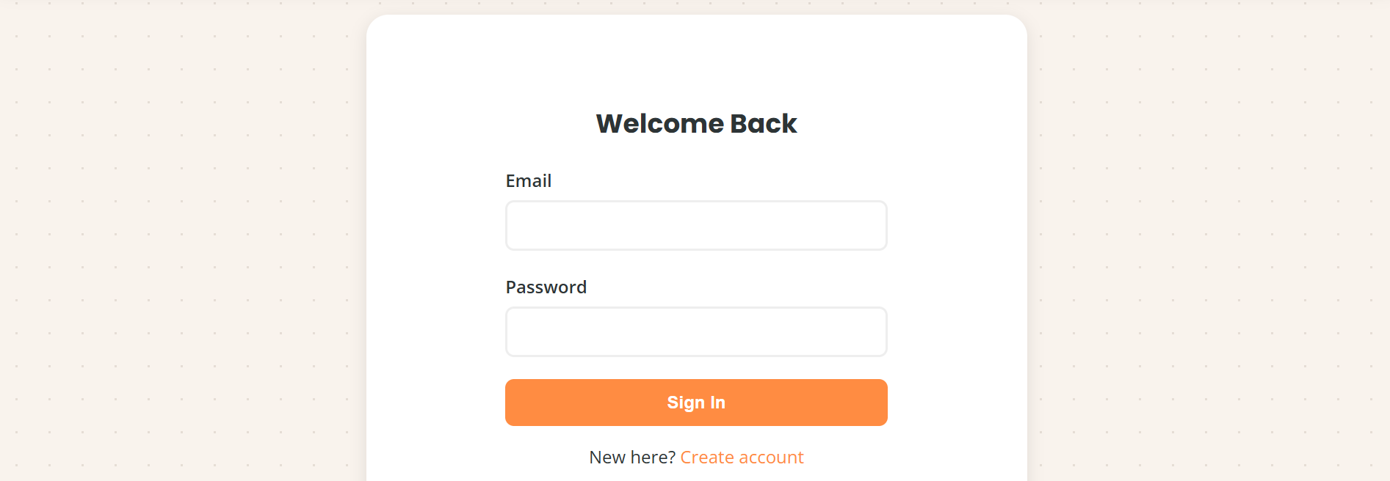



## Chat Gpt

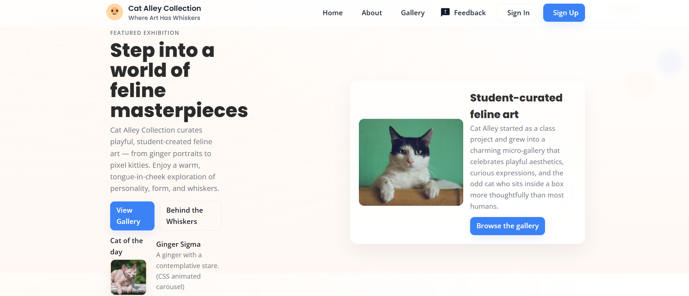

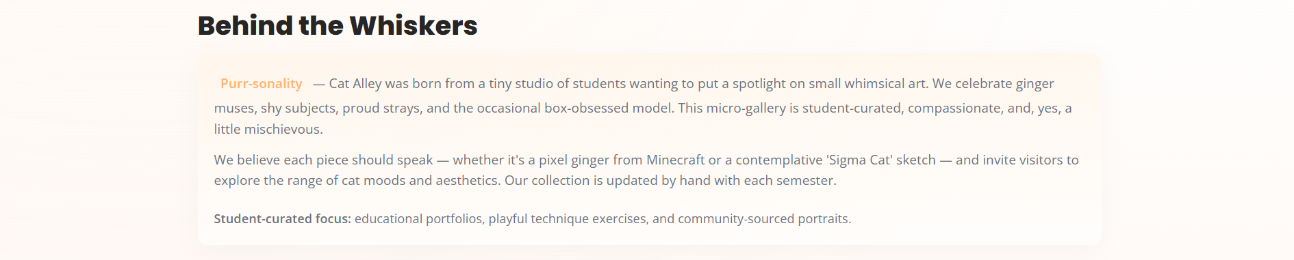

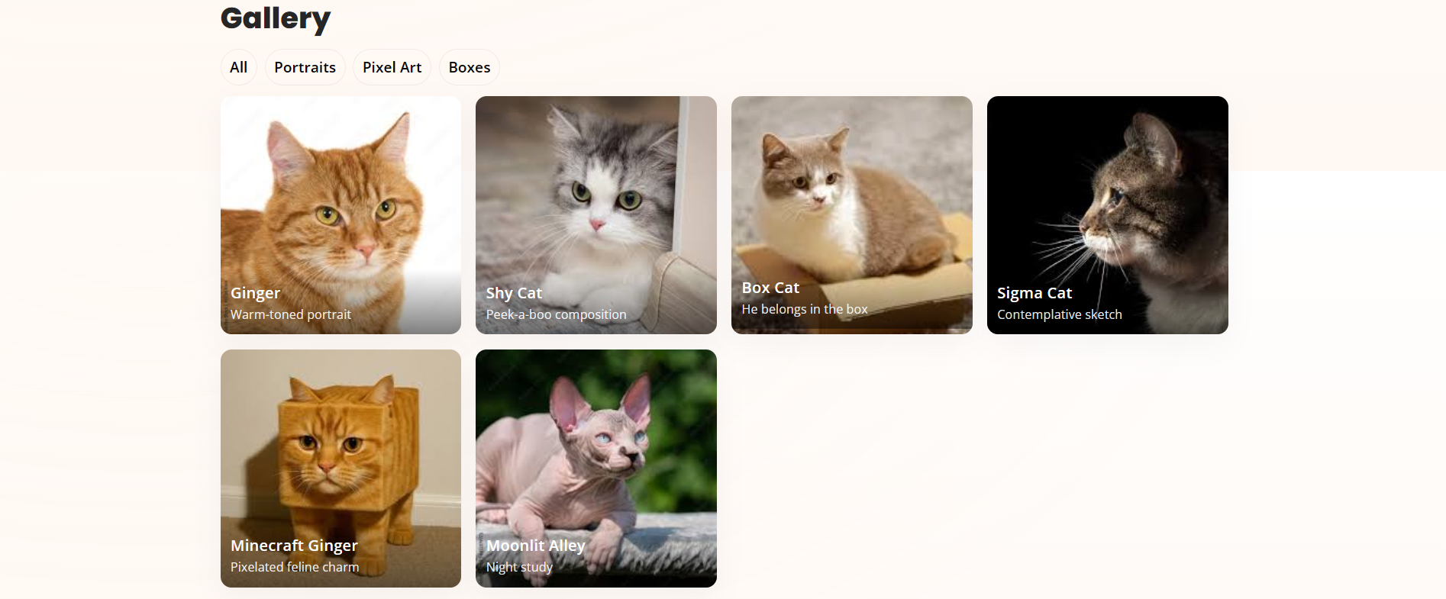

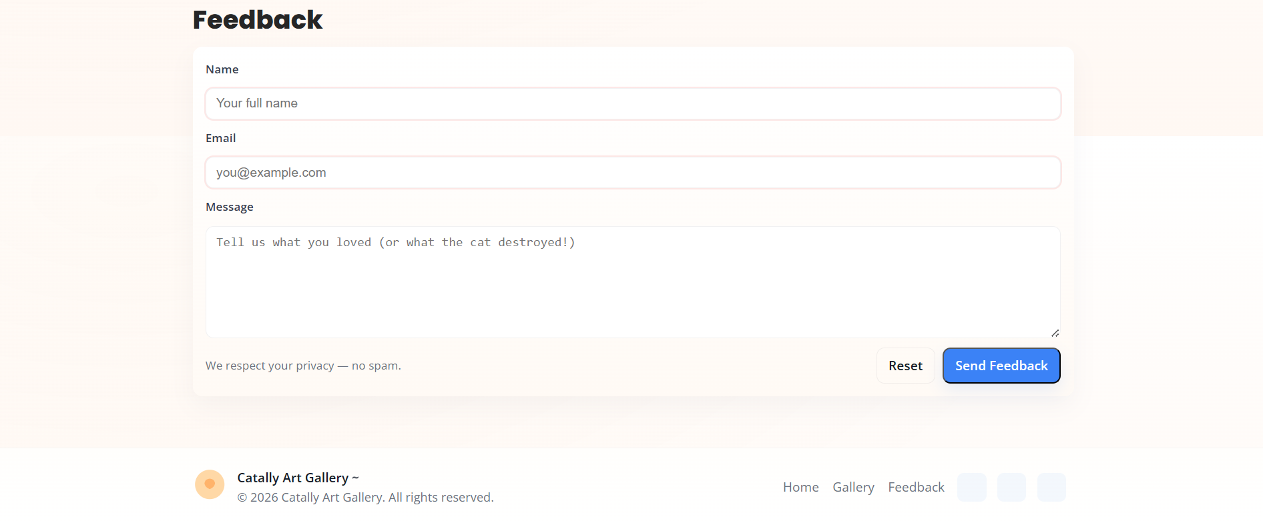

## Grok

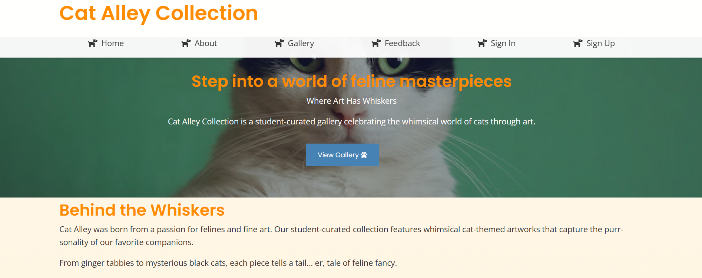

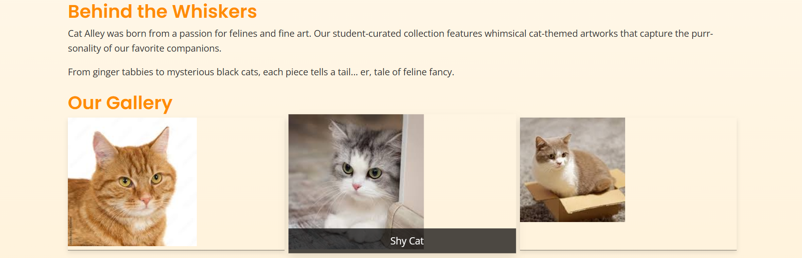

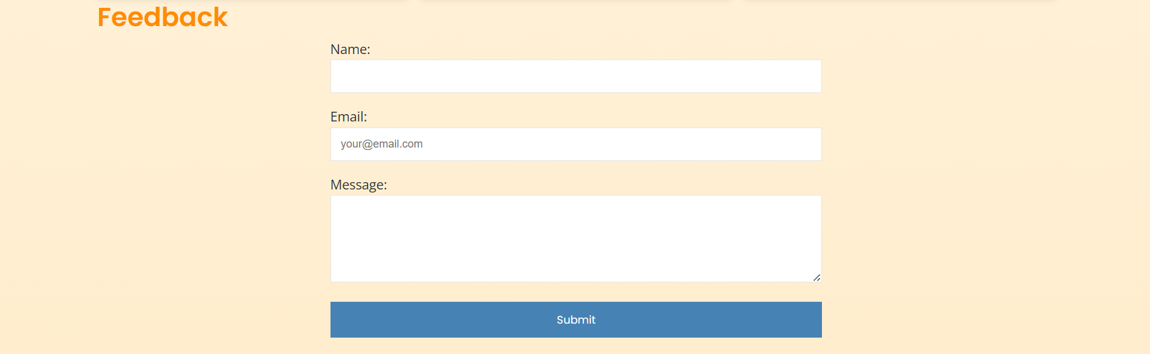

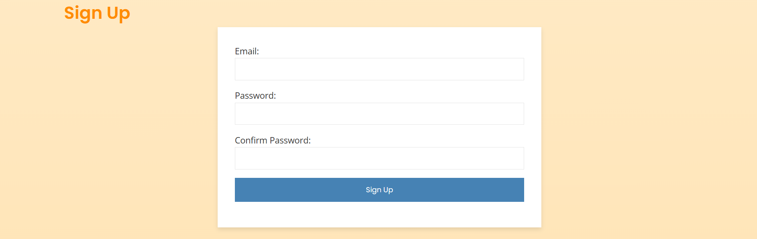

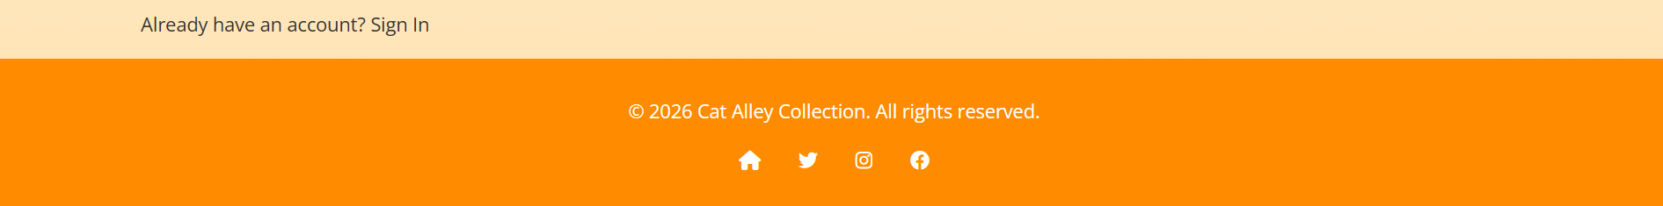

# AI Agent Comparison Ratings

1. Claude 4.5 Sonnet
2. Deep Seek (Deep think Mode)
3. Gemini 3 Pro
4. Chat GPT (Thinking Mode)
5. Grok (Expert)

# Analysis

## Claude

Claude did an outstanding job in understanding the assignment, for its creativity, and making a full and complete website. It added certain animations where possible, suitable and smooth transitions in all places, added a fully detailed footer, added icon, and most of all, it added complete responsiveness. The responsiveness even included the perfect collapsing of the navigation bar, which opened by clicking the 3 bars. The bars turned into a cross and vice versa through animation. It also has hidden the signup and sign in form and only one of them appeared when we clicked the respective button (which no other AI had done). The startup also had animation. I would give Claude 10/10 for the perfect, complete website.

## DeepSeek

Deep seek also did a very great job. It added a startup animation, organized website with everything, animations and transitions, detailed footer, all links were functional, added icon, and it also tried to collapse the nav bar but failed to make it functional because it wouldn’t open or close. The rest was all good. I will give it 9/10.

## Gemini

Gemini added all the basic functionality like added box shadows, transitions, the nav bar, a simple footer which was exactly same one as given in prompt (not anything extra), added forms, and like all these things were just the basic needed CSS elements for a good-looking website. It also collapsed the navbar, but it wasn’t functional as well. It was also missing a signup form. I will give it 8/10.

## Chat GPT

Chat GPT implemented all the mentioned things like all the pages, the forms, added a cat of the day card too as a bonus, but it lacked the aesthetic sense. Its navigation bar wasn’t fixed. It didn’t have many transitions. It had some empty space on the side because of signup button. It had extremely poor responsiveness because of its static navbar. Although, the unique things were the translucent navbar and that the sign in and signup forms opened in on the page like sub window, which was its unique feature. I will give it 5/10.

## Grok

Grok did a terrible job and just implemented the bar minimum. Like it implemented all pages with all forms too, but there were no animations, except just the hover animation on gallery images. Its navbar was also translucent, but it overlapped the pages and it hadn’t handled the offset. It had no scrolling animations; its forms didn’t have any boundary. I will give it 2.3/10.

# Conclusion

Overall, most of the AI agents did a good job in understanding the assignment and adding something extra or unique in addition to the original thing because they wanted to put in some creativity. But still they can’t beat the creativity of human minds. In my opinion, these top rated chatbots should be used to implement what we want on our instructions, because our ideas and their code will make a perfect, efficient website.